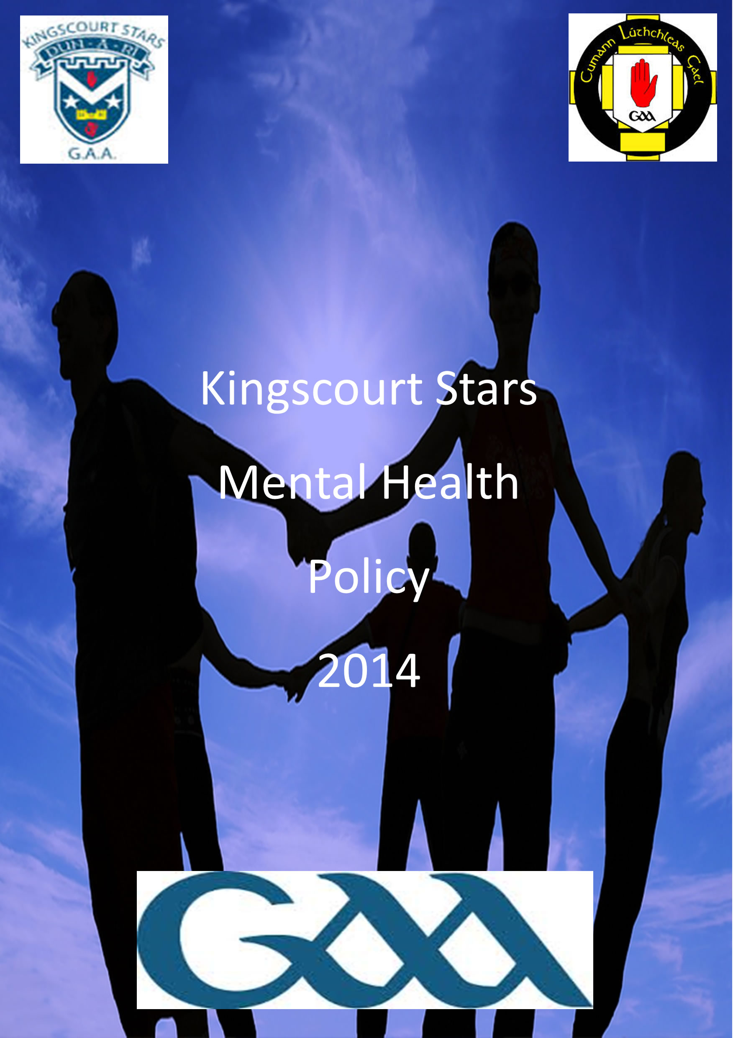

Contents

Introduction... Page 1
Description of Mental Health... Page 2-3
Common Causes of Mental Health Distress.... Page 4
Promoting Positive Mental Health... Page 5
Kingscourt Stars approach to Mental Health. Page 6-11
Conclusion... Page 12
Contact listings for support services... Page 13

P1
Introduction

Mental Health is something we all have, something we all cope with. It is our duty to look after our mental health in the same way as we look after our physical health. Mental Health is defined by the World Health Organization as “a state of well-being in which every individual realises his or her own potential, can cope with the normal stresses of life, can work productively and fruitfully, and is able to make a contribution to his or her own community” (www.who.int) Good mental health is vital to us all.
As Ireland’s largest sporting and community organisation the GAA has always played a pivotal role in promoting health and well being among all its members and players. By its very nature GAA clubs are health-promoting units offering excellent opportunities for physical exercise, social interaction, community engagement and a safe environment for recreational activities, intergenerational connections, and promoting life skill development for one and all.
Kingscourt Stars, its officers, volunteers, and most importantly your team mates provide a valuable support system to help members and communities overcome challenges they may face from time to time. While all this happens organically within our club, the Association in conjunction with Kingscourt Stars has put in place dedicated structures to drive and support this health agenda at national level through the GAA Community & Health Section in Croke Park.
Kingscourt Stars strength is our ability to reach into every individual within our parish, and work in the area of health and wellbeing. It will be largely dependent on appropriate partnerships with organisations that have the requisite expertise, knowledge and resources. Kingscourt Stars very much supports the mantra of ‘healthy bodies, healthy minds’ and we wish all our members every success and enjoyment in maintaining their mental fitness.
For more info see www.kingscourtstars.ie and www.gaa.ie.

P2
What is Mental Health?
The term “Mental Health” refers to how a person thinks, feels and acts when faced with challenging life situations, It describes a sense of well-being and it implies the capacity to live in a resourceful and fulfilling manner and having the resilience to deal with the challenges and obstacles that everyday life presents. The concept of ‘Mental Health’ as it is used in this policy document is broader than the mere definition of what mental health is.
Mental well-being, mental health difficulties and mental disorder/illness are each a complex manifestation of a range of biological, psychological, social, cultural and historical variables that affect the thoughts, emotions and behaviour of an individual when faced with everyday life situations.
In it’s 2006 report “A Vision for Change” commissioned by the HSE, the Expert Group on Mental Health emphasised the following:
“A model for understanding mental health needs to be formulated because the way mental health is viewed (i.e. the model used) determines society’s approach to emotional distress and mental health problems. If there is no understanding of what factors influences mental health, we cannot hope to promote better mental health or to prevent mental health problems”. (www.mhcirl.ie)
Mental well-being is associated with an individual’s ability to live in a productive and self-fulfilling manner, having the resilience to cope effectively, when faced with the challenges and stressors that are a part of everyday life.

P3
Mental Illness
Mental illness is the term used to refer to severe mental health difficulties. Mental illness includes conditions such as schizophrenia, bipolar disorder, depression, anxiety/panic disorders, obsessive compulsive disorders, eating disorders and attention-deficit / hyperactivity disorder, members who experience mental health issues may require treatment and support from a health professional such as a Psychiatrist, Counsellor or General Practitioner
Mental Health Distress
Mental health distress can be associated with a wide range of experiences that affect how we think, feel and behave which may result in a less than effective ability to cope with and manage our lives, change in our lifestyle or a new environment may manifest, which may lead to signs of mental health distress, signs to look out for which may include, among other factors,
- Low-level anxiety or depression,
- Poor concentration and performance,
- Difficulty with eating (or eating to excess),
- Withdrawal from peer group,
- Alcohol and narcotic abuse,
- Excessive gambling
- Changed behaviour and appearance,
- Suicidal ideation,
- Obsessive attitude towards work/pre-occupation with failure
“It is important to note that mental health distress may be experienced by anyone at any time and the World Health Organisation maintains that one in four individuals will experience

P4
Mental Health distress at some point in their lives. The experience will not necessarily warrant specialist mental health care or admission to a specialist facility”. (www.who.int)

Common Causes of Mental Health Distress
Many members will experience periods of varying degrees of distress and stressors during their life. Events such as bereavement, parental separation, unplanned pregnancy, relationship breakdown, injury, unemployment and addictions can be traumatic and distressing for members. In addition, the transition that happens when you go from primary school to secondary school, university to adulthood or the development that a player faces at different age groups from U-8 right up to seniors, the highs and lows of championship competition can be common sources of stress and stressors. These may be signs or signals to look out for in the onset of mental health issues.
Warning Symptoms
- Withdrawal from friends, family, school and sport.
- Mood changes or inappropriate responses to certain situations.
- Disturbed sleeping patterns.
- Lack of care for appearance and personal responsibilities.
- Drop in personal performance, be it work/school/sport.
It is important to note that with established and new members the support networks available will vary from individual to individual, whether they are still residing at home with family, or living away from home for the first time, or whether they have previously had access to or been supported by Mental Health Services.
Kingscourt Stars will undertake to promote and build on existing supports, by providing access to additional sources of help when necessary, a member that may be experiencing Mental Health difficulties where it may interfere with his/her capacity to function, or where it
P5
may be persistent, he/she may benefit from accessing a Counsellor, Nurse, GP, Priest/Minister or Health and Wellness Officer.

Our approach to promoting Positive Mental Health
Kingscourt Stars take great pride in the positive working relationship with our local health centre and counsellor Patrick O’Rourke as an outside qualified source specialising in the area of psychotherapy. Both are available to contact if issues arise for members. As part of the community it is important that all members know there is help available if needed and can be contacted in the strictest confidence.
Local Health Centre,
This facility is the first purpose-built primary care health centre in the North East HSE region. It is a centre of excellence which accommodates local GP’s, a practice nurse, public health nurses and visiting health professionals such as counselling services.
Counselling Services,
Kingscourt Stars are delighted to have a working relationship with Patrick O’Rourke who works in the field of Cognitive Behavioural Therapy (CBT). This approach focuses on present thinking, behaviour and communication rather than on past experiences and is oriented toward problem solving. Cognitive therapy has been applied to a broad range of problems including depression, addiction, anxiety, panic, fears, eating disorders, substance abuse, and personality problems”. (www.medterms.com)
Patrick O’Rourke, in conjunction with Kingscourt Stars, will introduce himself to club member and players. Our aim is to show club members and players that support structures are in place, as this will allow players and members to feel comfortable knowing that if his services are required. Players and members will feel at ease knowing who he is and what supports he will be providing in a private and confidential environment. Kingscourt Stars, in conjunction with Patrick O’ Rourke, will also provide talks on best practice on how to look after your mental health with club teams.
P6
Kingscourt Stars approach to minding your Mental Health
Accept yourself
We are all different, but one thing we all have in common is that no one is perfect. There are many different things which set us apart for example, the colour of our skin, our gender, our religion and our sexuality. These factors play a defining influence on who we are. One thing that we can offer and are entitled to is respect and understanding, both to ourselves and towards others.
SELF-HELP DO’S AND DON'TS
COMMUNICATION
- Do talk to someone you can trust.
- Do listen to someone you trust.
- Do arrange to meet with a friend.
- Don’t isolate yourself or spend too much time alone.
- Don’t keep things bottled up.

LIFESTYLE CHOICES
- Do go outdoors when you can.
- Do eat a balanced healthy diet.
- Do make room for some quality relaxation time.
- Do include others.
- Do get a good night’s sleep.
- Don’t exist within a social media bubble (every waking moment spent on social media)

P7
- Don’t avoid friends, family, coaches and team mates.
- Don’t take on too many commitments.

POSITIVE ATTITUDE DEVELOPMENT
- Do explore additional interests other than GAA.
- Do be aware of how your thoughts influence your mood.
- Do accept mistakes.
- Do accept that you can’t win them all.
- Do from time to time give yourself a pat on the back.
- Don’t be impatient.
- Don’t worry about what others may think.
- Don’t let bad performance get you down.
- Don’t feel guilty it’s not your fault.
- Don’t put too much pressure on yourself.

Ask for help
If you are physically ill or injured, you would visit your local GP so why feel different about seeking help for your Mental Health? Everyone needs help or support in their lives on different occasions and there is nothing unusual about seeking support and guidance if matters arise. Seeking help is a sign of personal strength not weakness.

First Call Support
Where a member is considered to be in some distress and in need of extra support the following can be the first port of call.

P8
Family.... A member’s family can often be the first people to notice changes, Simple acts like talking, showing support and caring can be a big help, Your emotional strength will allow you to provide the ongoing support your friend or family member needs.
Team mates and friends...... If a team mate and/or friend is in distress they may look to you their fellow team mate and friend. This is an important position as it shows trust. Listen in a confidential manner and seek advice but do not promise secrecy, explain that you may need to seek the advice of a professional.
Counselling and health services.... If you feel that a team mate, friend or family member may require the services of a qualified professional, or you may have concerns, it is often helpful to seek advice from a qualified professionals on how to proceed. Club representative Patrick O’Rourke is available in this instance. Kingscourt Stars are privileged to have a productive working relationship with Patrick, who is an outside qualified source specialising in the area of psychotherapy and is available to contact in the strictest confidence.
Family Doctor/General Practitioner... Provides support advice and treatment for physical and mental health issues. Your Doctor is usually the first person you may approach in relation to mental health concerns. Many people attend their General Practitioner (G.P.) with mental health problems such as depression or anxiety and will not need the help of a psychiatrist or counsellor. In other cases the G.P. may decide to refer you to members of the mental health team such as a Psychiatrist, Clinical Psychologist or a Counsellor.
Health and Wellness Officer.... Kingscourt Stars has an elected Health and Wellness Officer who provides support in aiming to achieve a healthy lifestyle. They will work with you on issues and goals that are primarily related to your health and wellbeing. They are also on hand to provide information on mental health, nutrition, exercise or substance worries that you may be encountering. Kingscourt Stars current officer is Joseph Farrelly.
Disability Support Service..... Our intention is to maximise our club members ability to speak and advocate for themselves. No club member is the same as another, each club member will have different needs and wants and as a club and organisation we will advocate for the need to adjust the way we work to reflect the variation of support we will provide all our members. If a member has a disability, information and advice is accessible through the Health and Wellness Officer.

P9

Support Groups..... In coping with any mental health problems, as well as obtaining qualified, medical help, it’s widely accepted that self-help from peer groups are a great way of coping with issues, in conjunction with any qualified, medical practitioners. Club members may endure alcohol or drug abuse or connected difficulties relating to gambling or eating. These can occur simultaneously or individually, resulting in compulsive behaviour relating to the particular “release”.

Members may find it hard to differentiate between the negative consequences of one versus the other. Support Groups such as Alcoholic’s Anonymous and Gambler’s Anonymous for sufferers and Al-Anon or Gam-Anon for family/friends of such sufferers offer a tremendous support to all connected parties in such scenarios and these meetings are widely available in the North-East Region.
Lifestyle
There is an abundance of evidence that lifestyle choices can affect mental health and that mental health affects standards of living (NIMHE 2005; Department of Health and Children 2006). Diet, exercise, sleep, alcohol and drug use all influence mental health much more than is commonly realised. Efforts to encourage healthy eating, increase physical activity and reduced alcohol and drug consumption can make a significant contribution to improving emotional well-being and cognitive function.
Support
Support Groups provided by the GAA is also an important and useful resource. The GAA Healthy Club Project is a collaborative partnership between the GAA and the HSE which aims to assist GAA clubs in responding to the wide and varied health needs of their members, while extending the positive influences out to the wider community. Uachtarán CLG, Liam Ó Néill, and Chief Medical Officer at the Department of Health, Dr Tony Mollohan, jointly launched the project on the 11th of March 2013, reflecting the close relationship between the GAA and the HSE. (www.gaa.ie)
P10
Kingscourt Stars Approach to Mental Health
- Promote mutual respect at all times.
- Include and welcome everyone to the club.
- Not tolerate negative attitudes or behaviour.
- Give everyone a voice and take time to listen and talk.
- Create a safe environment where enjoyment is paramount.
- Accept decisions of club management gracefully.
- Highlight participation, good sportsmanship and achievement.
- Link with external agencies to seek training, help and support when necessary.
- Encourage everyone to be involved and ensure fair play, equality and enjoyment.
- Support all club members and reassure them that there is someone who can help.
P11
Respect

Everyone will show respect towards all members

Enjoy
Kingscourt Stars promotes, above all, the enjoyment of our national games in a safe and fun environment

Kingscourt Stars aims to promote mental health by providing a healthy lifestyle.

Support
Use the support around you. Your coaches, club mates, family can help
Encourage
Ensure everyone is treated equally and fairly and encourage everyone to do their best

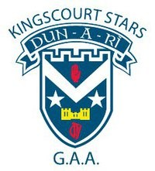
Participate
All are welcome to participate in every aspect of Kingscourt Stars GAA club

Communicate
Kingscourt Stars strives to value every member’s voice by listening and communicating, Everyone’s voice is valued

P12
Conclusion
In the past, mental health has been a major stigma in our culture as a nation, as it comes to the front of our consciousness. Kingscourt Stars, as an association, realise what a vital issue mental health is and will continue to work to promote positive mental health.
Kingscourt Stars aims to produce an environment where our mental health needs are just as important as our physical needs. We are part of a parish, community and culture that surrounds all of us, as a community we face issues with a positive mindset and above all look out for each other’s health and well being.
This document strives to underline our commitment to our members to allow them to flourish in a safe and friendly environment and be prepared for all issues faced by our members. It will continue to be updated and promoted within Kingscourt Stars and the GAA.
Our Club recognises the important role which sport plays in promoting positive mental wellbeing. Respect forms the basis of our club and members will encourage enjoyment, teamwork and discipline We adopt the values within this document and will make every effort to ensure that these are reflected in the overall operations of our club.

____________________________ ______ _____________________
Philip Smith Joseph Farrelly
Chairman Health & Wellness Officer
Kingscourt Stars Kingscourt Stars

P13
Legislation Relating to Mental Health
There are several Acts relevant to mental health, including:
Mental Health Act 2001
Equal Status Act 2000 - 2004
Disability Act 2005
Kingscourt Stars and its members will always use their best endeavours in dealing with members with mental health difficulties or mental illness.
Support Services
The services listed below have experience in helping people to overcome any difficulties and problems they may have had. If you wish to speak to someone in the strictest confidence the following contacts are available.
NAME | ADDRESS/ TITLE | CONTACT DETAILS
Patrick O’Rourke BSc | Cognitive Behaviour Therapist | 087 0514394 saoirsepor@yahoo.co.uk www.patrickorourkepsychotherapy.ie
Local Health Centre | Kingscourt, Kells Road, Kingscourt Co Cavan | 042 9667487
Joseph Farrelly | Club Health and Wellness Officer | jfarrel5@tcd.ie
SoSad | 6A Parnell Street, Carricmacross Co Monaghan | 0429668992, 0860459168 carrick@sosadireland.ie
St. Patrick’s University Hospital Helpline: | Support and Information Centre | 01 249 3333  www.stpatricks.ie
Aware Helpline: | Helping defeat depression | 1890 303302  www.aware.ie
Pieta House Helpline | Centre for prevention of self harm & suicide | 01 601 000  www.pieta.ie
Samaritans Helpline | 24HR support line for anyone who needs to talk to someone, about anything. Official mental health partner & support service for the GAA | Helpline: 1850 6060 90 www.samaritans.org
Alcoholics Anonymous | Support Group for Individuals | 01-8420700  www.alcoholicsanonymous.ie
Gamblers Anonymous/ Gam-Anon | Support Group for Individuals & Family/Friends | 01-8721133  www.gamblersanonymous.ie
Narcotics Anonymous | Support Group for Individuals | 01- 6728000  www.na-ireland.org
Bodywhys | Support Group for Individuals | 1890 200 444  www.bodywhys.ie
Al-Anon | Support Group for Family/Friends | 01 8732699  www.al-anon-ireland.org

Kingscourt Stars GAA Club Elected Officers
Positions | Elected Officers | Contact Details
Chairman | Phil Smith | 087 2793291
Vice Chairman | Pat Faulkner | 087 2294591
Secretary | Sean Kieran | 085 1740880
Assistant Secretary | Niall Reilly | 087 6006818
Treasurer | Niall Smith | 087 9937447
Assistant Treasurer | Kieran Lynch / Frank Boylan | 087 2467690
Health and Wellness Officer | Joseph Farrelly | 087 9418085
Ladies Football Officer | Pat Farrelly | 087 2552957
Youth / Juvenile Officer | James Brown | 086 8640380
PRO | Colleen McCabe | 087 9001860
Culture Officer | Jim McGovern | 087 2321886
Registrar | Gabriel Patterson | 087 2568600
Insurance Officer | Anthony Corcoran | 087 9080829
Development & Infrastructure Officer | Colm Kieran | 087 6218740
Child Protection Officer | Louise Mc Keown | 086 8814669
Games Development Officer | Colm Smith | 086 8807354
Ground Maintenance Officer | Tommy Reilly | 087 2226614
Players Representative | Alan Clarke | 086 3353134

